Hengyue Liu

4107-2966-75

hengyuel@usc.edu

CSCI574 Homework #2

September 30, 2015

# Homework 2 Report

## Problem 1

“Gray world” assumption states that each channel component is averaged to a gray value.

It is required to use the “gray world” assumption to estimate RGB color of the incident light. And re-render the images with “white” light conditions. The basic steps are as follow:

1. Calculate the mean value for each channel using CvScalar avgChan=cvAvg(img);
2. Each channel mean are supposed to converge to the mean double avgRGB=(avgB+avgG+avgR)/3;
3. Normalize each channel’s gain factor avgR=avgRGB/avgR;(same for G, B)
4. Change each pixel value per channel I->I*avgR.(same for G, B)
5. Export the re-rendered image.

Test results are shown below:

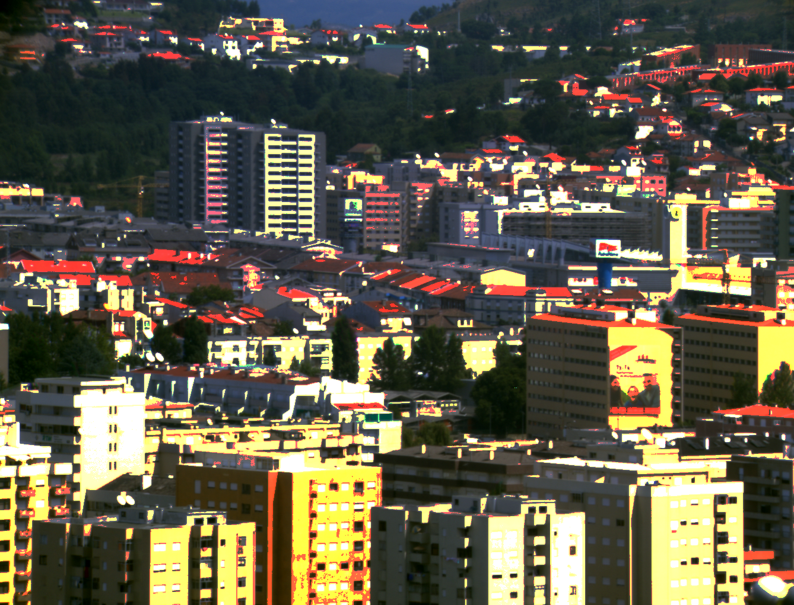

Figure 1 Re-rendered image of 'colo1.bmp'

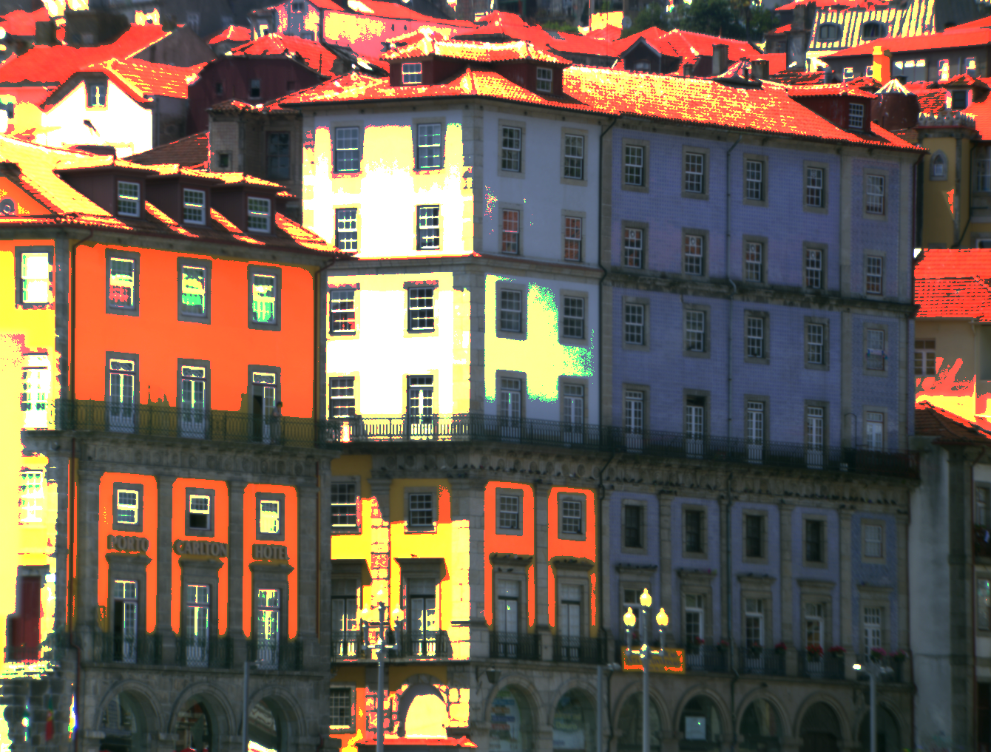

Figure 2 re-rendered image of 'color2.bmp'

### Analysis and Discussion

From the re-rendered results, it can be drawn that the images’ luminance is a little higher than it should be. This is because when changing the RGB values of the original image, one certain channel gets larger gain (>1). As a result, some values may be higher than 255, and if so, set them to 255. The image is brighter than the original image. Another way is that, one can find the max value of each channel, then map all values from original range to 0-255. The performance of the “gray world” assumption is dependent on input images, so it can give bad performance for different images.

## Problem 2

Use mean-shift filter to perform image segmentation is one fast way. The basic steps are as follow:

1. Read image file as ‘Mat’, then convert color space to CIELab using cvtColor().
2. Create Trackbars to listen and change the spatial and color window radiuses of meanshift filter using createTrackbar().
3. Apply meanshift filtering to the converted image using pyrMeanShiftFiltering().
4. Show the image and manipulate the parameters (pyramid level is set to 1).

Some results are shown below:

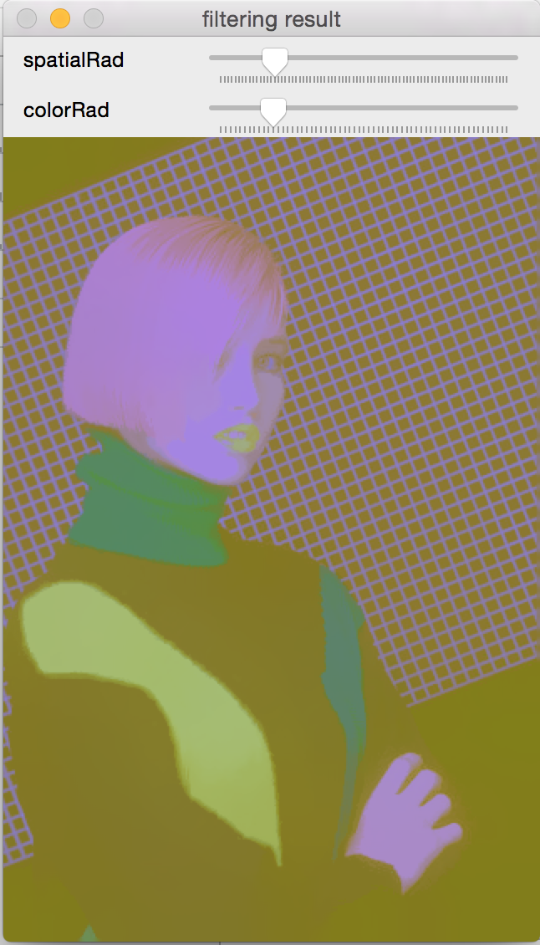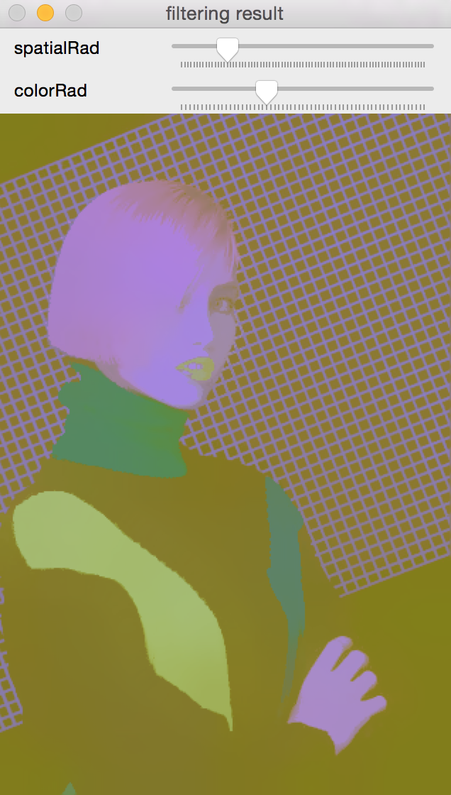

Figure 3 spatialRad=15; colorRad=11; Figure 4 spatialRad=15; colorRad=21;

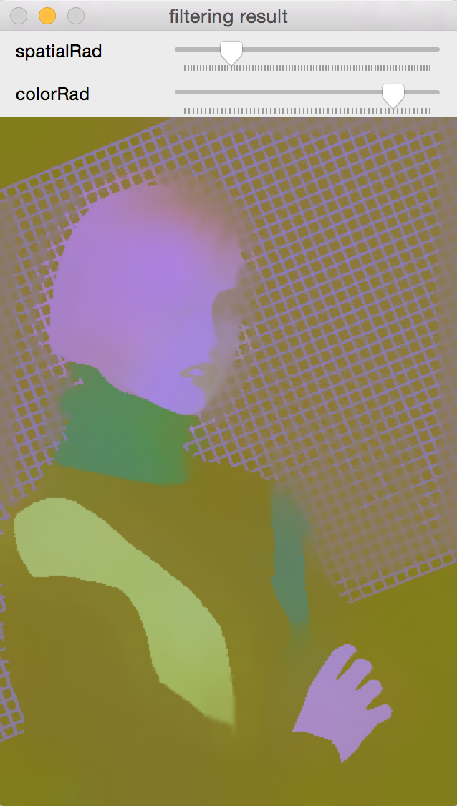

Figure 5 spatialRad=15; colorRad=51;

### Analysis and Discussion

For analyzing the influence of spatial radius and color radius, one easy way is to study each parameter individually. First, fix the spatial radius to 15, then change the color window radius. *ColorRad* are set to 11, 21 and 51 for comparison.  *Figure 3* is a little big blurry, and this is because color radius is small so that at the edge, the meanshift vector considers small number of intensity values. As a result, the image is not well segmented but preserves fine details at eyes and neck, etc. *Figure 4* is a great segmentation result compared with *figure 3.* The edge is sharp enough and image preserves fine details too. As for *figure 5*, the result performance is interesting. The lips are included in the face segmentation, which should be an individual segmentation. Since the color radius is large, the color differences are averaged causing the loss of details like lips and eyes. It is good if details are not important, for example, one just want to use 4 color segmentation in this image. On the other hand, it can be really useless if one wants to find the lips. In conclusion, the color window radius controls the number of neighbors’ intensity values. With increasing the radius, the number of segmentations decreases.

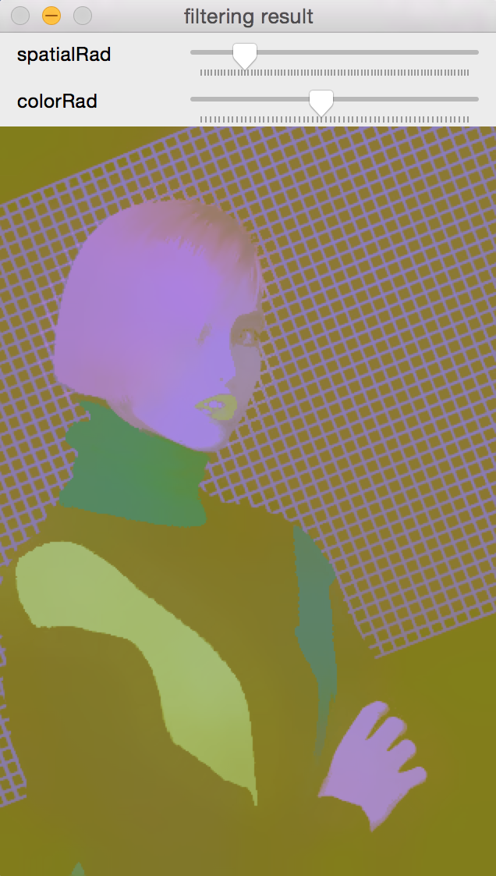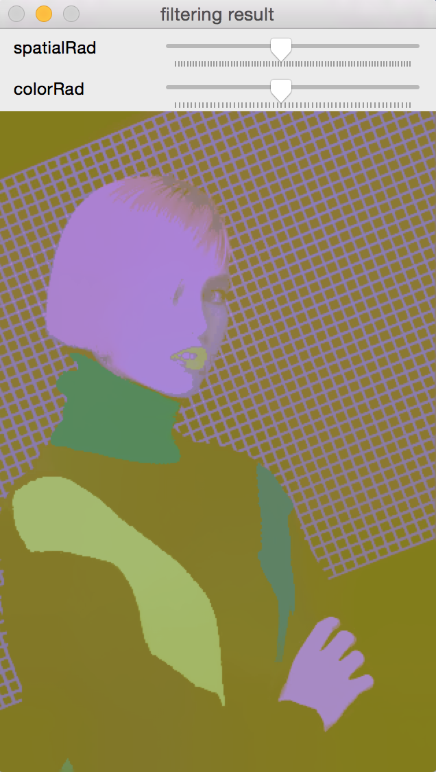

Figure 6 spatialRad=13; colorRad=27; Figure 7 spatialRad=36; colorRad=27;

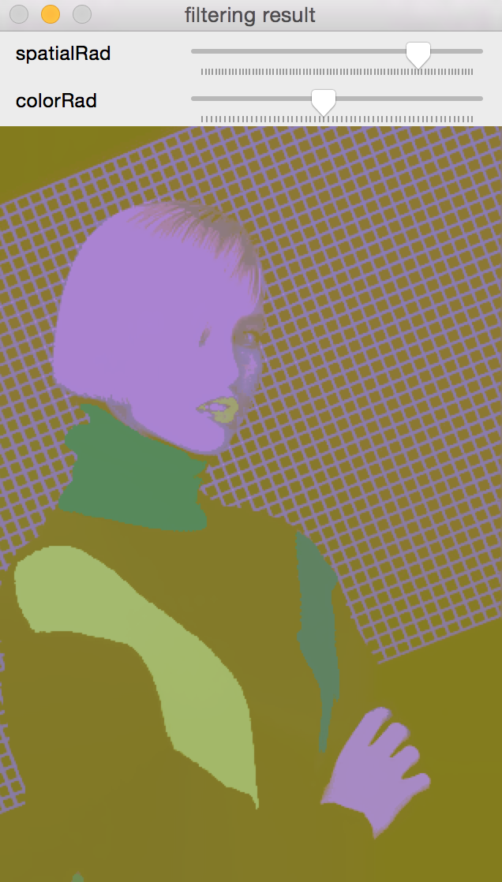

Figure 8 spatialRad=64; colorRad=27;

In this part, fix the color radius to 27, then change the spatial window radius. *SpatialRad* are set to 13, 36 and 64 for comparison. On the contrary, the spatial kernel has the inverse influence compared with color window radius. *Figure 6* already has good enough segmentation result. Figure *8* has the most segmentations and greatest details that the shading of face can be seen clearly. This can be good or bad based on the segmentation requirement. Hence, with increasing the spatial radius, the number of segmentations increases.

By the observations of the performance of those two parameters, one reasonable segmentation result is shown below:

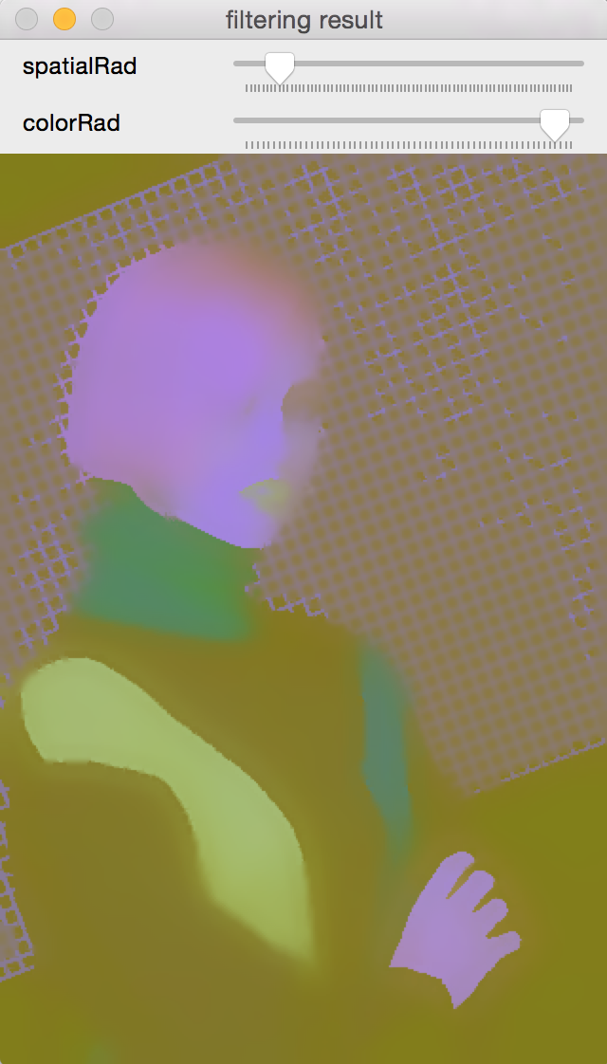

Figure 9 spatialRad=8; colorRad=50;

This result discards fine details like hair and eyes but preserves main segmentations area like lips and eyes.

The analysis of the other two images are similar, here give the results of segmentation below:

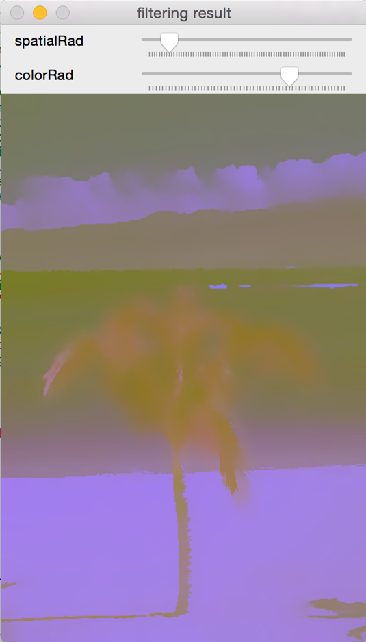

Figure 10 result of '46076.jpg' spatialRad=8; colorRad=43;

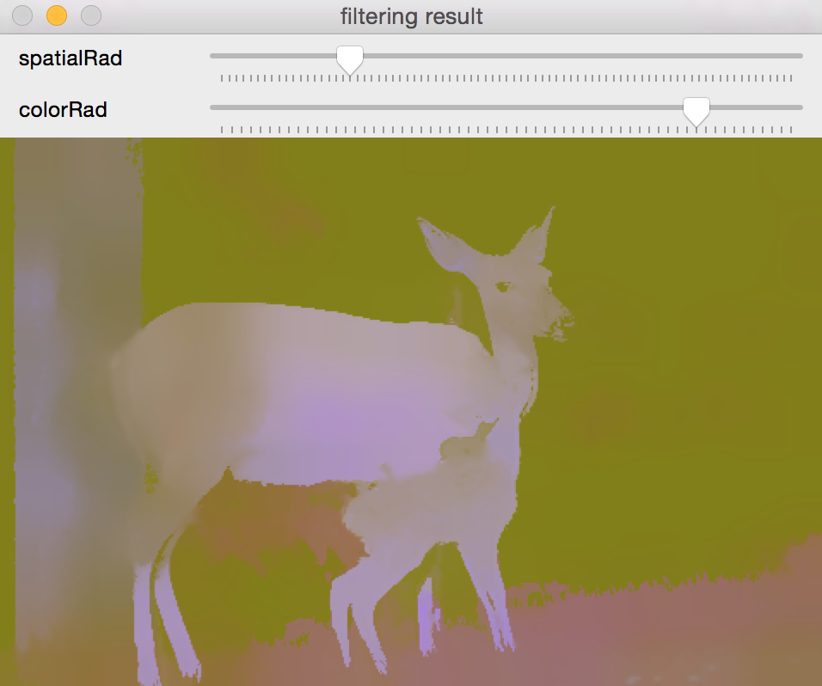

Figure 11 result of '317080.jpg' spatialRad=18; colorRad=50;

Note:

The color is wired because the Lab color space of 8-bit jpg is mapped like this:

Original intensity:

0 <= L <= 100

-127 <= a <= 127

-127 <= b <= 127

After CvtColor():

L = L * 255 \ 100, a = a + 128, b = b + 128

So, the color is different from original color, but it does not matter for segmentation.

## Appendix

//

// main.hpp

// 574hw2

//

// Created by LiuHengyue on 9/26/15.

// Copyright © 2015 LiuHengyue. All rights reserved.

//

#ifndef main_hpp

#define main_hpp

#include <stdio.h>

#include <stdio.h>

#include <opencv2/opencv.hpp>

#include <opencv2/highgui/highgui.hpp>

#include <opencv/cvaux.h>

#include <opencv/cxcore.h>

#include <iostream>

using namespace std;

using namespace cv;

#endif /* main_hpp */

// Editor: Xcode 7.0

// main.cpp

// CSCI574 Homework #2

// Created by LiuHengyue on 9/26/15.

// Copyright © 2015 LiuHengyue. All rights reserved.

#include "main.hpp"

/*******************************

below function is for problem 1

******************************/

// Gray world Assumption Implementation

// Given an image, export an new re-rendered image with "white" light conditions

void GrayWorldRender(){

const char* PATH_1="/Users/liuhengyue/Desktop/574hw2/hw2/color1.bmp";

const char* PATH_2="/Users/liuhengyue/Desktop/574hw2/hw2/color2.bmp";

const char* SAVEPATH="";

//enter the input: 1 2 . The index numbers represent 2 different images

IplImage* img;//initial an image

cout<<"please enter the index of images (1, 2) you want to re-render: ";

cin.ignore();//dealing with '\n' input

// Load an image from file - 1 parameter for color image, bmp colormodel is RGB

char index;

index=cin.get();

if(index=='1'){

img=cvLoadImage(PATH_1);

SAVEPATH="/Users/liuhengyue/Desktop/574hw2/hw2/color1_rerendered.bmp";

}

else if(index=='2'){

img=cvLoadImage(PATH_2);

SAVEPATH="/Users/liuhengyue/Desktop/574hw2/hw2/color2_rerendered.bmp";

}

else{

cout<<"error when load image."<<endl;

}

//IplImage* img2=cvLoadImage("/Users/liuhengyue/Desktop/574hw2/hw2/color2.bmp");

//create a new image to store the gray world re-rendered image

IplImage* img_rendered=cvCreateImage(cvGetSize(img), img->depth,img->nChannels);

//IplImage* img2_rendered=cvCreateImage(cvGetSize(img), img->depth,img->nChannels);

//cvCvtColor(img2, img2_gray, CV_RGB2GRAY);

if(img==0)

{

cout<< "failed to load input image\n";

//return -1;

}

//Calculate the average value for each channels of original image 'img', and assign mean values for each channel

CvScalar avgChan=cvAvg(img);

double avgB=avgChan.val[0];

double avgG=avgChan.val[1];

double avgR=avgChan.val[2];

//Calculate the mean of 3 channels

double avgRGB=(avgB+avgG+avgR)/3;

//normalize each mean value, avgR(G,B) is the gain for each channel

avgR=avgRGB/avgR;

avgG=avgRGB/avgG;

avgB=avgRGB/avgB;

//search all image pixel values

int col,row;

for( row = 0; row < img->height; row++ )

{

for ( col = 0; col < img->width; col++ )

{

//Blue channel

//find the re-rendered value of pixel at (row, col) in original image, and then assign the value to the new image

if(u_int(img->imageData[img->widthStep * row + col * 3])*avgB <= 255){

img_rendered->imageData[img_rendered->widthStep * row + col * 3]=img->imageData[img->widthStep * row + col * 3]*avgB;

} else {

//if the re-rendered value is over 255, make it to 255 in case of overflow

img_rendered->imageData[img_rendered->widthStep * row + col * 3] = u_char(255);

}

//Green channel

if (u_int(img->imageData[img->widthStep * row + col * 3 + 1])*avgG <= 255) {

img_rendered->imageData[img_rendered->widthStep * row + col * 3 + 1]=img->imageData[img->widthStep * row + col * 3 + 1]*avgG;

} else {

img_rendered->imageData[img_rendered->widthStep * row + col * 3 + 1] = u_char(255);

}

//Red channel

if (u_int(img->imageData[img->widthStep * row + col * 3 + 2])*avgR <= 255) {

img_rendered->imageData[img_rendered->widthStep * row + col * 3 + 2]=img->imageData[img->widthStep * row + col * 3 + 2]*avgR;

} else {

img_rendered->imageData[img_rendered->widthStep * row + col * 3 + 2] = u_char(255);

}

}

}

//create a window to display the new image

cvNamedWindow("gray world re-rendered image",CV_WINDOW_AUTOSIZE);

//show the new image

cvShowImage("gray world re-rendered image",img_rendered);

//show the original image

cvNamedWindow("original image",CV_WINDOW_AUTOSIZE);

cvShowImage("original image", img);

//Save the re-rendered image to file

cvSaveImage(SAVEPATH, img_rendered);

cout<<"press any key to close the image window"<<endl;

cvWaitKey(0);//this commend is for displaying the image windows then hold

//release images data and header

cvReleaseImage(&img);

cvReleaseImage(&img_rendered);

}

/*****************************

Below codes are for problem 2

*****************************/

//define global variables:

//img: the original loaded image matrix, 3 optional images to select

//img_Lab: convert img to this image with Lab color space

//img_segmented: filtered result of img_Lab

//spatialRad and colorRad stands for the filter parameter spatical window radius and color window radius

Mat img,img_Lab,img_LabFixed,img_segmented;

int spatialRad,colorRad;

//call back function for trackbar

//display current spatial/color radius

//do the meanshit filtering to the image, then show the result image

static void meanShiftSegmentation( int, void* )

{

cout << "spatialRad=" << spatialRad << "; "

<< "colorRad=" << colorRad << "; "<<endl;

//The maximun pyramid level is set to 1 according to problem 2 description

pyrMeanShiftFiltering( img_Lab, img_segmented, spatialRad, colorRad, 1 );

imshow( "filtering result", img_segmented );

}

//read image file then apply meanshift filter to it

int PyrMeanShift()

{

//enter the input: 1 2 3. The index numbers represent 3 different images

cout<<"please enter the index of images (1, 2 or 3) you want to use this filter: ";

cin.ignore();//dealing with '\n'

char index;

index=cin.get();

if(index=='1'){

img=imread("/Users/liuhengyue/Desktop/574hw2/hw2/198023.jpg");

}

else if(index=='2'){

img=imread("/Users/liuhengyue/Desktop/574hw2/hw2/46076.jpg");

}

else if(index=='3'){

img=imread("/Users/liuhengyue/Desktop/574hw2/hw2/317080.jpg");

}

else{

cout<<"input value invalid, please restart."<<endl;

return -1;

}

//change the color space BGR to LAB, because of 8-bit image, the Lab values are shifted

cvtColor(img, img_Lab, CV_BGR2Lab);

//create a window to display the results

namedWindow( "filtering result", WINDOW_AUTOSIZE );

//create trackbars for spatical radius and color radius for pyramidMeanShift Filter

createTrackbar( "spatialRad", "filtering result", &spatialRad, 80, meanShiftSegmentation );

createTrackbar( "colorRad", "filtering result", &colorRad, 60, meanShiftSegmentation );

meanShiftSegmentation(0, 0);//call back

cout<<"press any key to exit program"<<endl;

cvWaitKey(0);//for exit program

return 0;

}

int main(int argc, char** argv)

{

cout<<"type problem number 1 or 2: "<<endl;

char index;

index=cin.get();

if(index=='1'){

GrayWorldRender();

}

else if(index=='2'){

PyrMeanShift();

}

else{

cout<<"error input."<<endl;

}

return 0;

}